(E1.1) Describe typical sensors that can measure each of the following:

Linear position、Velocity (or speed)、Nongravitational acceleration、Rotational position (or angle)、Rotational velocity、Temperature、Pressure、Liquid (or gas) flow rate、Torque、Force

Ans.

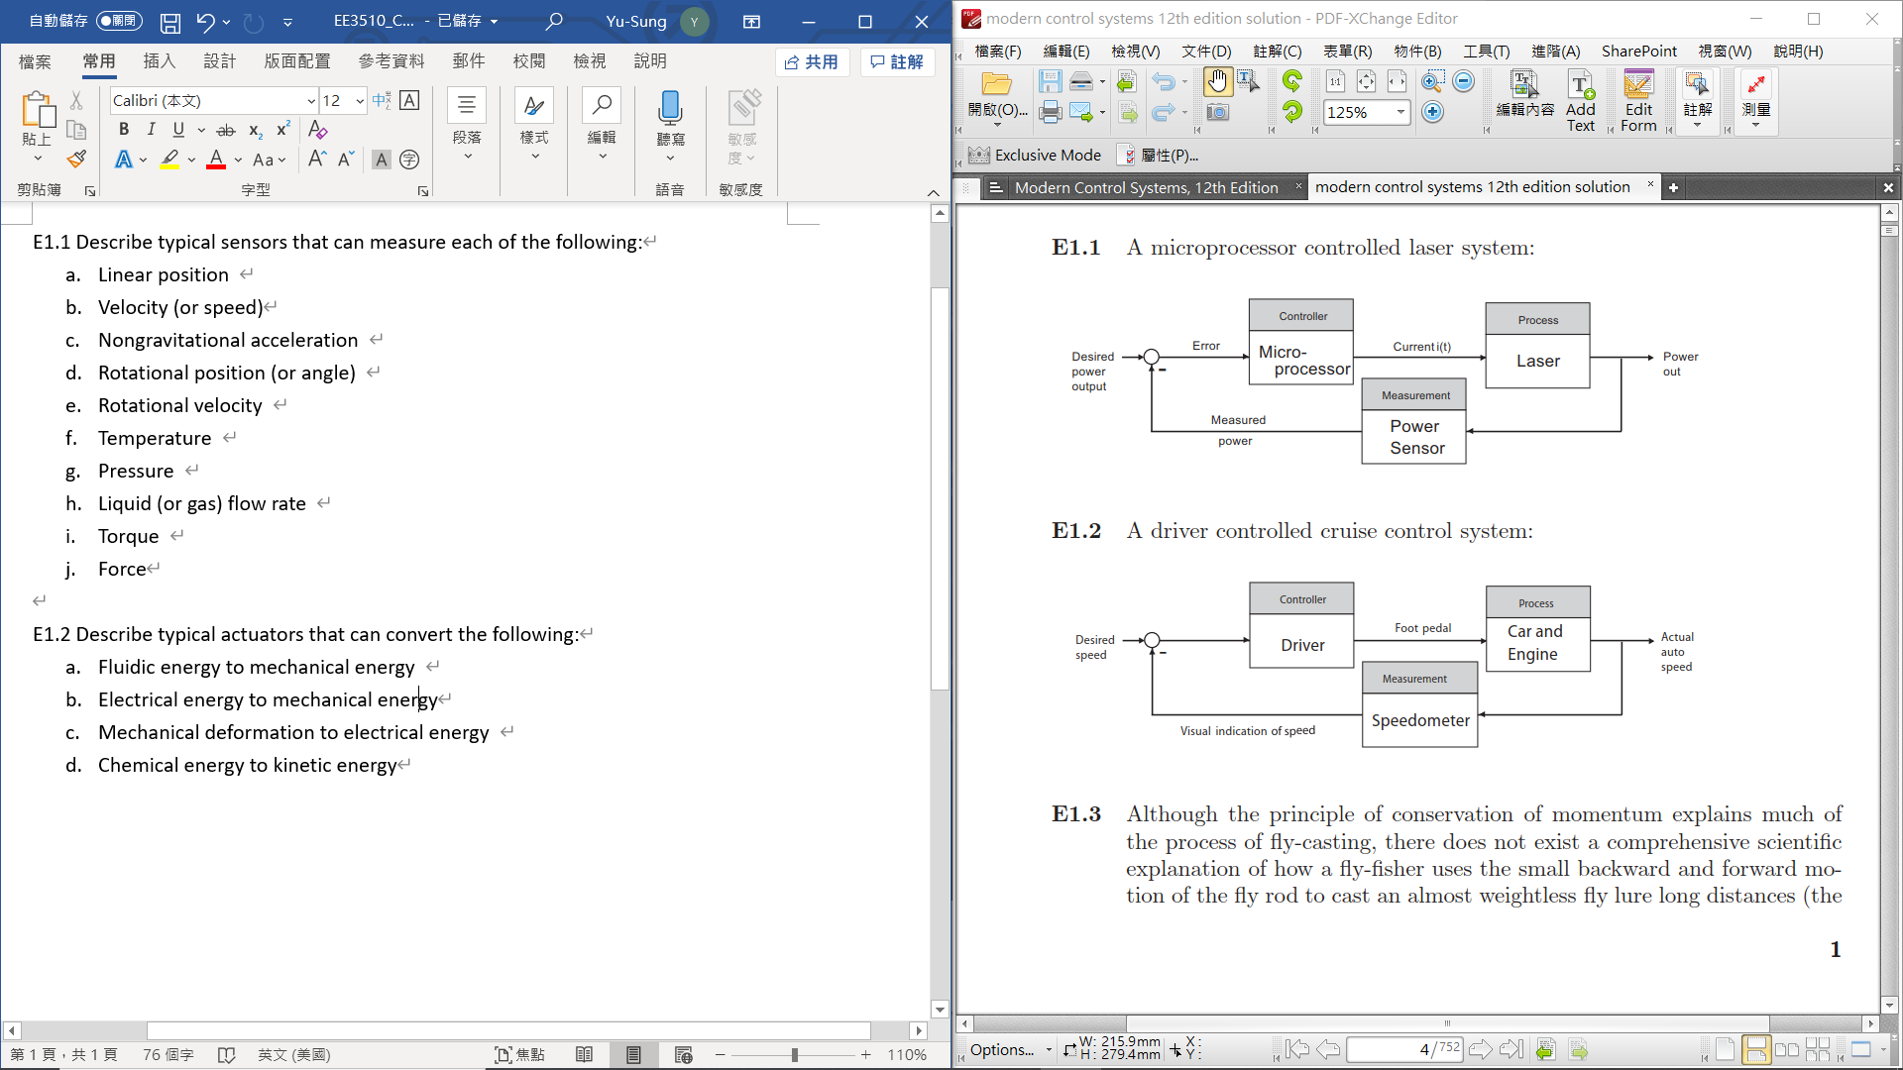

(E1.2) Describe typical actuators that can convert the following:

Fluidic energy to mechanical energy、Electrical energy to mechanical energy、Mechanical deformation to electrical energy、Chemical energy to kinetic energy

Ans.



(E1.13) Consider the inverted pendulum shown in Figure E1.13. Sketch the block diagram of a feedback control system using Figure 1.3 as the model. Identify the process, sensor, actuator, and controller. The objective is keeping the pendulum in the upright position, that is to keep 6 = 0, in the presence of disturbances.

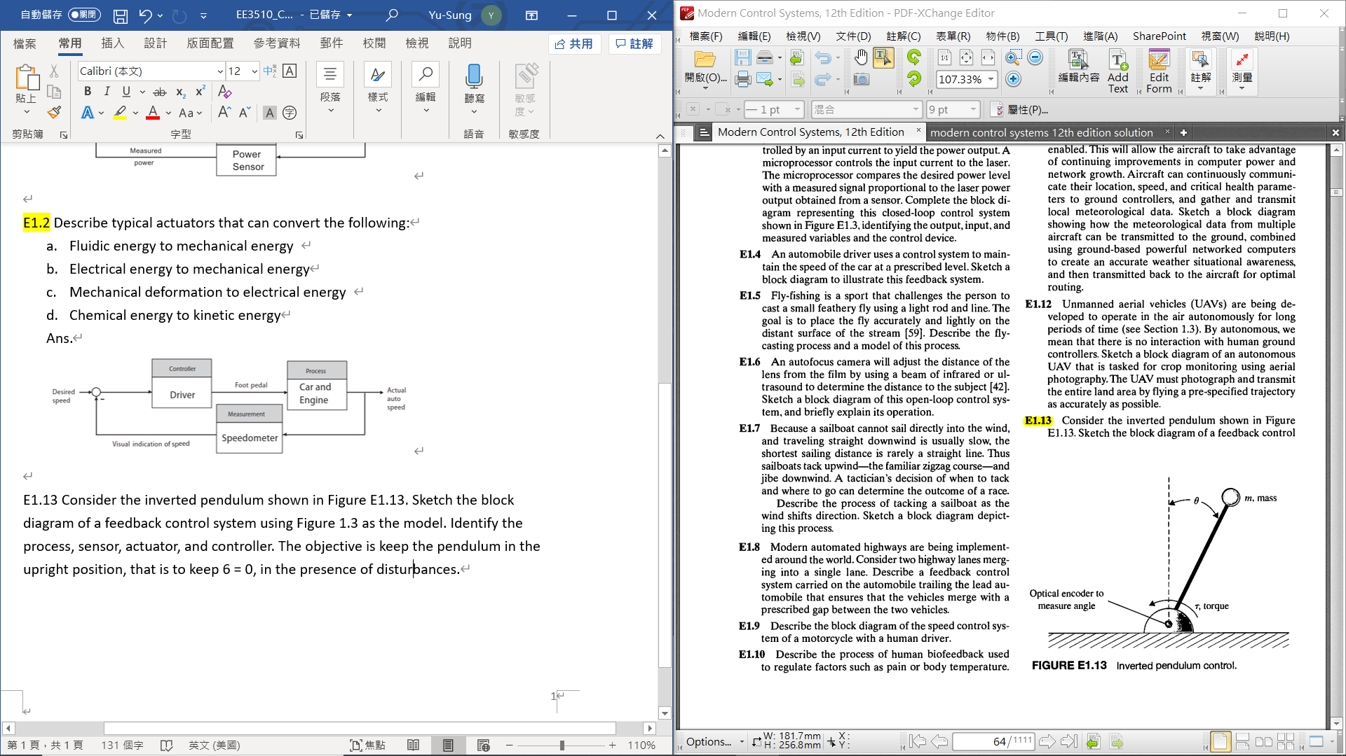

Ans.

???

(P1.2) In the past, control systems used a human operator as part of a closed-loop control system. Sketch the block diagram of the valve control system shown in Figure.

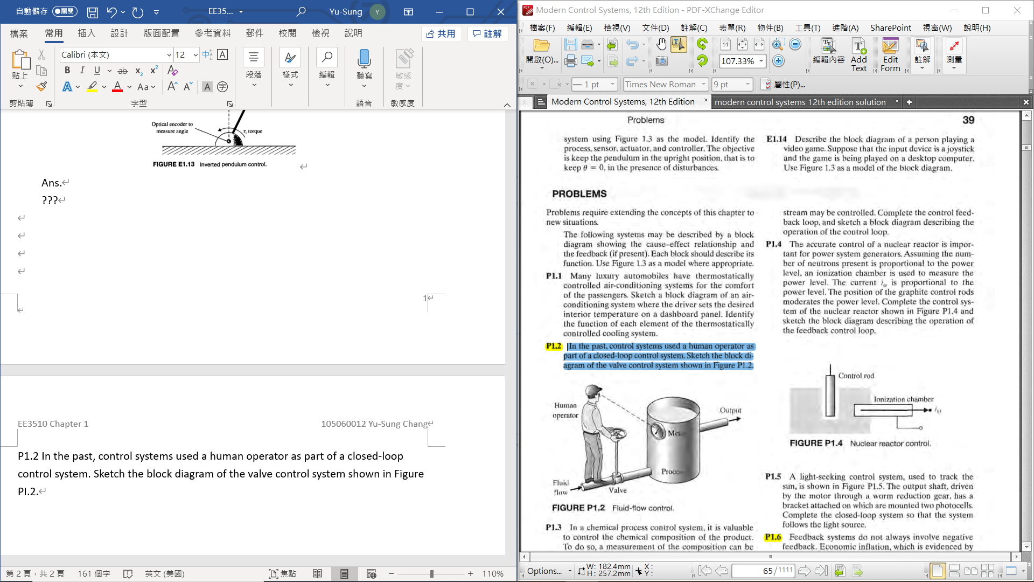

Ans.

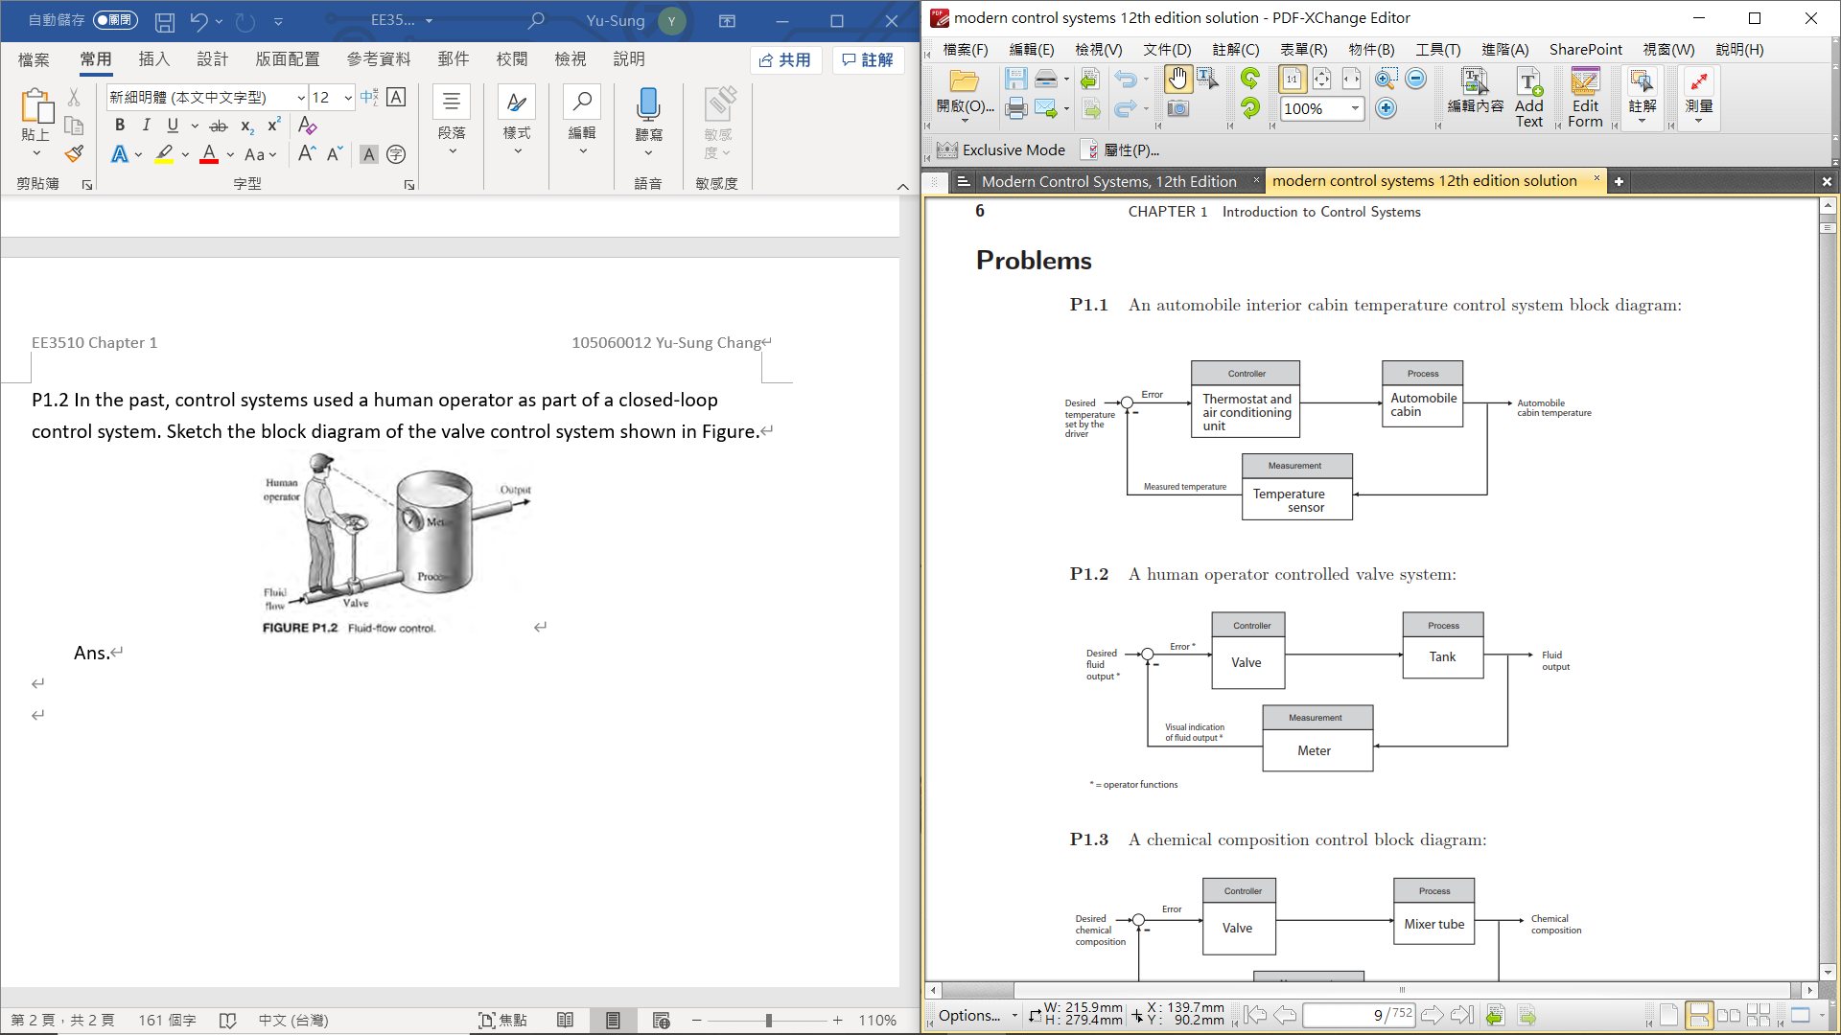

(P1.6) A simple model of the price-wage inflationary spiral is shown in Figure PI.6. Add additional feedback loops, such as legislative control or control of the tax rate, to stabilize the system. It is assumed that an increase in workers' salaries, after some time delay, results in an increase in prices. Under what conditions could prices be stabilized by falsifying or delaying the availability of cost-of-living data? How would a national wage and price economic guideline program affect the feedback system?

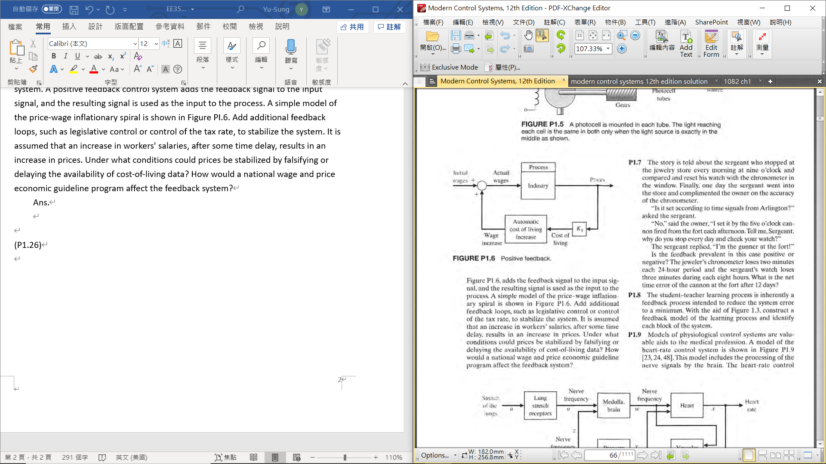

Ans.

If you assume that increasing worker’s wages results in increased prices, then by delaying or falsifying cost-of-living data you could reduce or eliminate the pressure to increase worker’s wages, thus stabilizing prices. This would work only if there were no other factors forcing the cost-of-living up. Government price and wage economic guidelines would take the place of additional “controllers” in the block diagram, as shown in the block diagram.

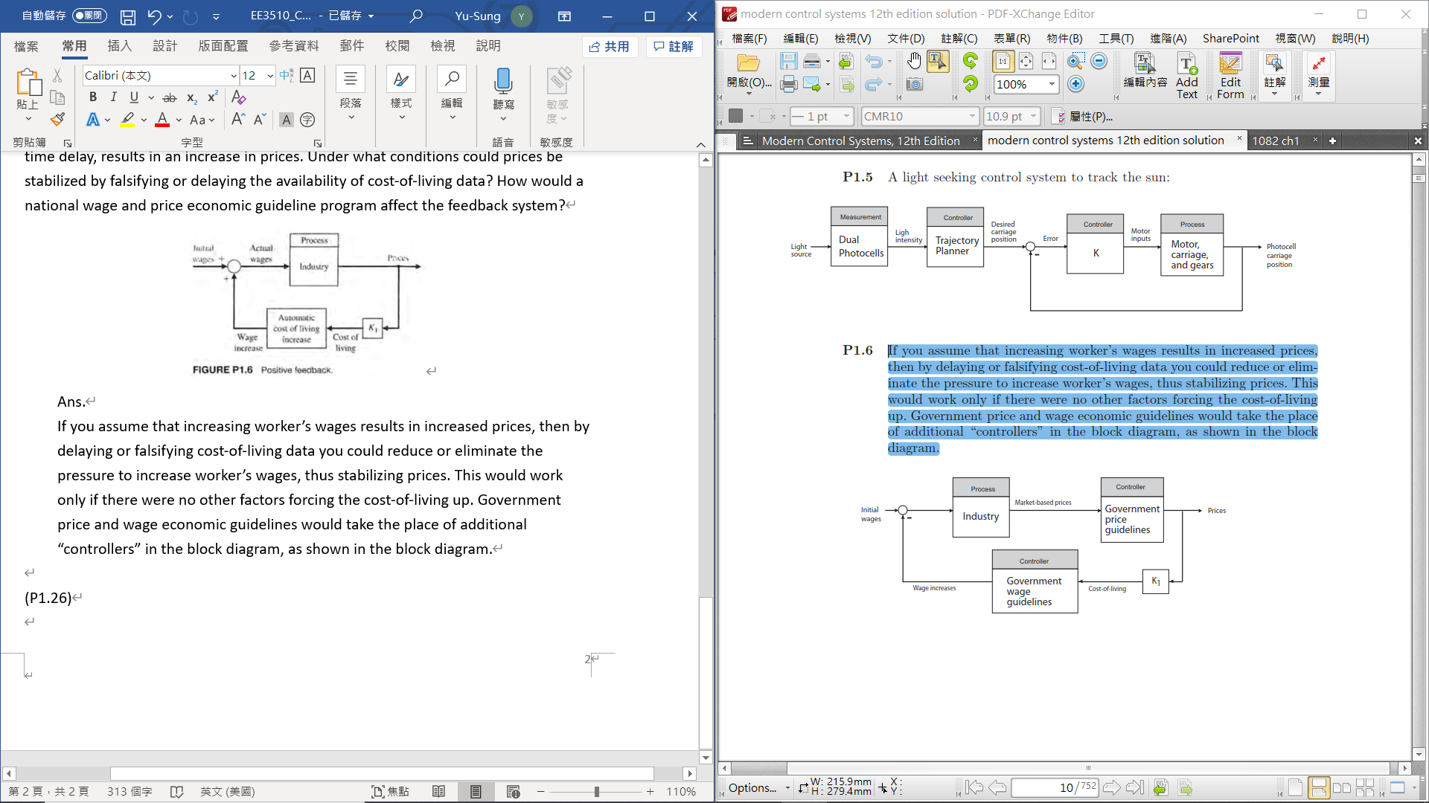

(P1.26) NASA is developing a compact rover designed to transmit data from the surface of an asteroid back to Earth. The rover will use a camera to take panoramic shots of the asteroid surface. The rover can position itself so that the camera can be pointed straight down at the surface or straight up at the sky. Sketch a block diagram illustrating how the micro-rover can be positioned to point the camera in the desired direction. Assume that the pointing commands are relayed from the Earth to the micro-rover and that the position of the camera is measured and relayed back to Earth.

Ans.

